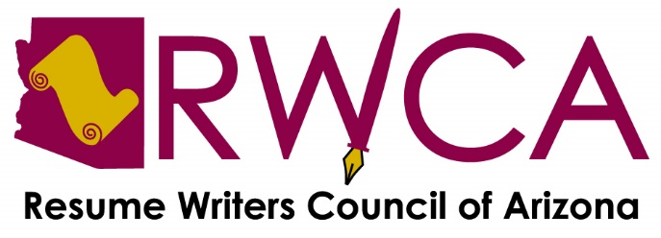

January 28, 2021 ● Virtual Meeting

Present: 11 members

Ríco Burton, Brenda Cunningham, Jeri Hird Dutcher, Amy Malouf, Maureen McGarrigle, Amanda Miller, Krista Morris, Lori Norris, Martha Rockwell, Donna Tucker and Lucie Yeomans

Call to Order and short meditation by Rico. Anyone interested in conducting a meditation in the future should contact Rico.

Adoption of Agenda Unanimously approved.

Meeting Minutes November meeting minutes approved as submitted.

President’s Report:
- RWCA is celebrating its 25th anniversary in 2021. Rico suggests celebrating all year long. She questioned about making a banner to highlight this achievement. Martha indicated her son is in the sign business and she would ask him if he could make one. This distinction will be featured at the HR Forum too. Donna indicated she was one of four resume writers who decided to form the organization in 1996. Most pictures of the group / events are up on the website.
- Ríco requested members to submit 30-second videos about their positive experience with RWCA for the web site and Facebook page.
- Rico has chosen “Reflect, Refine, Refresh” as the group’s 2021 theme.
- The Board will discuss which graphic designer to use to create a new logo. Amy has a contact and has offered to make an introduction if we desire.
- Virtual resume reviewers are still needed for multiple Career Connectors dates. Please contact Donna to volunteer.
- Donna is setting up officer-named emails for RWCA communications. The info@rwca.org email will be used for generic inquiries.
- Rico is establishing Thoughtful Thursday to post to our social media. These insights are meant to educate, enlighten and / or entertain.
- Kudos to Lori who set up and distributed invitations for the HR Forum on Eventbrite, which is saving the group time and money.

Treasurer’s Report:
- $1358.93 in the checking account; $1216.16 in the savings account.
- All holiday checks have been cashed.
- There are a few expenses pending.
- There is one dues renewal pending; Lori is waiting for a check from this member.

Vice President’s Report:
24th Annual HR Forum, February 25, 2021, 11 a.m. - 1:30 p.m.:
- Four nationally recognized career industry experts have been confirmed as speakers / panelists for the forum: Jennifer Goodfriend, Thomas Powner, Pat Criscito, Tiffany Hardy.
- It’s important to get the word out about the forum beyond the RWCA database. Talk it up to potential attendees.
- Lucie and Rico are putting together an e-book as a takeway for the forum, which will include content from the speakers and blog posts from our website. Donna will choose and forward to Lucie. If you have any effective tools you use and would like to add them to the e-book, please send to Lucie by February 10.
- Lucie indicated that Bridget Weide Brooks, author of Write Great Resumes Faster, has offered members her course entitled, “Ask Better Questions, Write Better resumes – as a group or individually – for $299. It is usually a $99 per person course. This includes an 87-page handout. We need a total of ten members to move forward with this opportunity. Each will each pay $30 for the course.

Teaching Tips & Tools:
- Rico alerted members to a website, AppSumo, that offers hundreds of free, and fee-based apps. Under separate email, secretary forwarded a link and promo code to save $10 on a fee-based purchase.
- Donna presented a punctuation lesson on dependent clauses.
- Krista showed members a new website and targeted job search tool, JobHack, that she and her husband have created since the pandemic began to assist virtual job searchers. She will forward the link to the website for members to review.
- Lori and Lucie will conduct a resume writing presentation to University of Arizona students.
- A 33-minute webinar presentation by Marie Plett on creating logos in MS Word concluded the member meeting.

Meeting Updates:
- By consensus, the group agreed to keep meetings on the 4th Thursday of the month but will change the time to 11:30 a.m. – 1:00 p.m. (except the HR Forum – see next bullet).
- Next meeting is the virtual HR Forum, 11:00 a.m. – 1:30 p.m. on February 25.
- First 2021 Board meeting, virtual, February 8 at 5 p.m. All members are welcome to attend.

Respectfully submitted,

Maureen McGarrigle
Secretary

